**Chemistry Topic 1 – Scientific Measurements**

|  |  |  |  |  |  |
| --- | --- | --- | --- | --- | --- |
| **Learning Intention**  We are learning about the challenges of making measurements and how to account for them. | | | | | |
| No, | **Outcome** | **What you know and understand** | ☹ | 😐 | ☺ |
| 1 | I can tell between an element, a compound and a mixture |  |  |  |  |
| 2 | I know what the reading uncertainties are in an analogue and digital scale. |  |  |  |  |
| 3 | I know whether results are accurate and/or precise |  |  |  |  |
| 4 | I can convert absolute uncertainties into relative uncertainties and vice-versa.  ***(Pre-IB only)*** |  |  |  |  |
| 5 | I know how to combine uncertainties in calculations  ***(Pre-IB only)*** |  |  |  |  |
| 6 | I can calculate the % reference error for a result compared to a literature value. |  |  |  |  |
| 7 | I know what the standard metric units are for length, mass, temperature and time |  |  |  |  |
| 8 | I know the metric prefixes are from pico to tera |  |  |  |  |
| 9 | I can calculate the density for an object including the correct unit. |  |  |  |  |
| 10 | I can work out the number of significant figures in a number and round numbers to the correct number of significant figures. |  |  |  |  |
| 11 | I can convert numbers into scientific notation and vice versa |  |  |  |  |

**Practice Questions**

1. Describe each of these boxes in terms of element, mixture and compound.

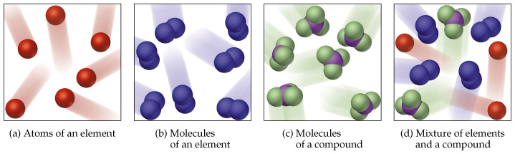

1. Describe these pictures in terms of accuracy and precision.

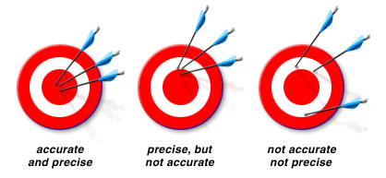

1. A block of wood 3 cm on each side has a mass of 27 g. What is the density of the block?
2. a) What is the reading uncertainty on this thermometer?

b) What is the temperature according to this thermometer?

c) What is the relative uncertainty in this measurement?

5. Write 639 000 000 in scientific notation and then 0.000456 also in scientific notation.

6. How many significant figures does 0.00102 have?

7. If the mass of a tablet is known to be 1.23g but a student found its mass to be 1.09g, what is the % error in their result?

8. 4 milligrams is how many kilograms?

**Key Words and Phrases**

|  |  |
| --- | --- |
| **Word/Phrase** | **Definition** |
| Element |  |
| Compound |  |
| Mixture |  |
| Accuracy |  |
| Precision |  |
| Reading uncertainty |  |
| Absolute uncertainty |  |
| Relative uncertainty  ***(Pre-IB only)*** |  |
| Reference error |  |
| Random error  ***(Pre-IB only)*** |  |
| Systematic error  ***(Pre-IB only)*** |  |
| Kelvin |  |
| Significant figures |  |
| Scientific notation |  |